Implementation of Network Scan Detection with Suricata and Wazuh

Objective
The objective of this lab was to detect Nmap reconnaissance activity against a Debian 13 system using Suricata and forward the generated alerts to Wazuh for centralized monitoring and alerting, also Test File Integrity Management in Wazuh.

Lab Architecture
The environment consisted of:
- Attacker Machine (Nmap)
- Debian 13 Target System
- Suricata IDS
- Wazuh Agent
- Wazuh Manager and Dashboard

Environment Details
Component | Version
Operating System | Debian GNU/Linux 13 (Trixie)
IDS | Suricata
SIEM | Wazuh
Scanner | Nmap
Virtualization | VirtualBox
Network Configuration | NAT + Host-Only Adapter

Step 1 – Verify Network Interfaces
The target machine was configured with:
- Adapter 1: NAT
- Adapter 2: Host-Only Network
Network interfaces were verified using:
ip -br a
Example:
enp0s3 UP 10.0.2.15/24 (NAT)
enp0s8 UP 192.168.56.102/24 (Host Only)
The Host-Only interface was used for scan detection testing.

Screenshot Placeholder
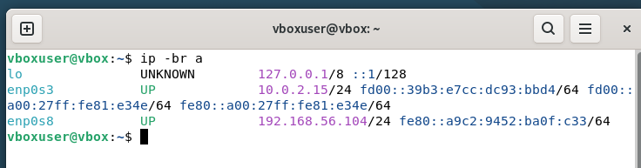

Step 2 – Install Suricata
Update package repositories:
sudo apt update
Install Suricata:
sudo apt install -y suricata suricata-update

Verify installation:
suricata --build-info
systemctl status suricata

Screenshot Placeholder
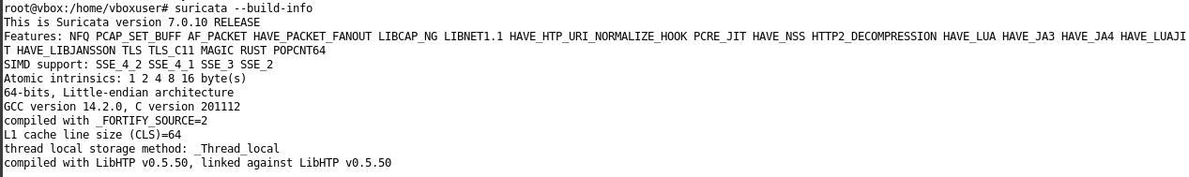
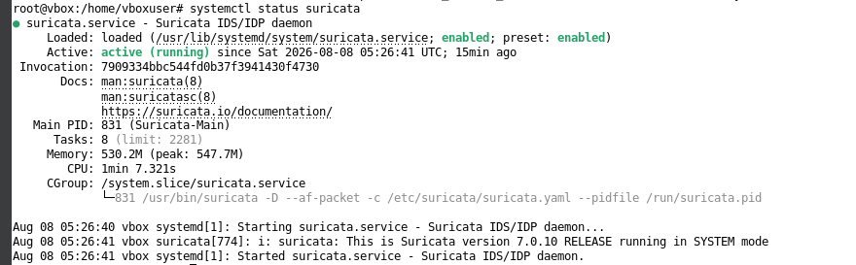

Step 3 – Download and Update Detection Rules
Suricata rules were updated using:
sudo suricata-update
Restart Suricata:
sudo systemctl restart suricata
Purpose:
- Download Emerging Threats rules
- Enable detection of reconnaissance activity
- Keep signatures updated

Screenshot Placeholder
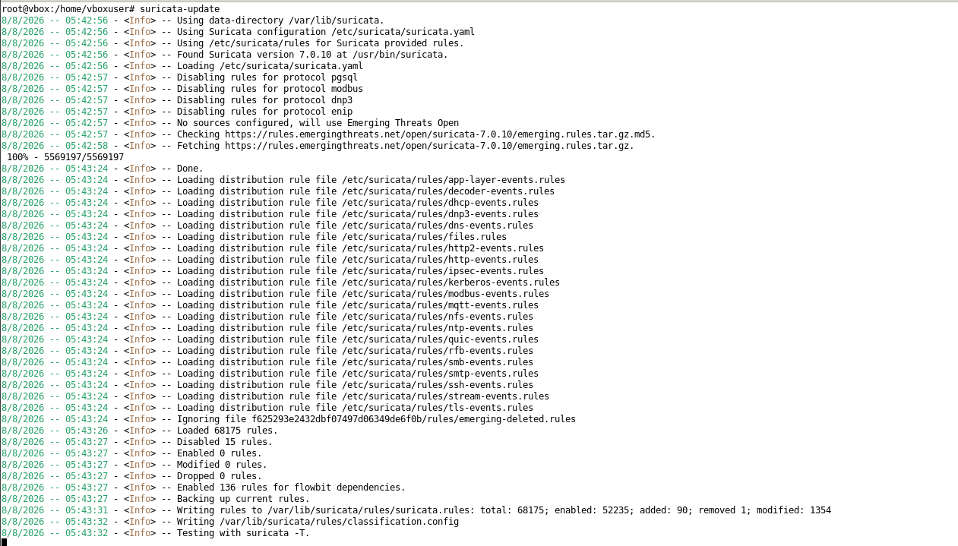

Step 4 – Configure Suricata Interface Monitoring
Configuration file:
sudo nano /etc/suricata/suricata.yaml
Modified section:
af-packet:
- interface: enp0s8
Reason:
The Host-Only adapter receives Nmap traffic generated from the attacker VM. I also added enp0s3 interface so I could test the working.
Validate configuration:
sudo suricata -T -c /etc/suricata/suricata.yaml
Restart service:
sudo systemctl restart suricata

Screenshot Placeholder
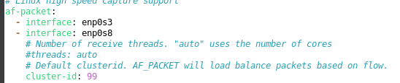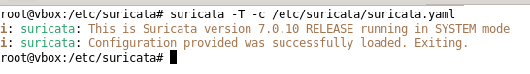

Step 5 – Enable Eve JSON Logging
Verified the following configuration:
outputs:
- eve-log:
enabled: yes
filename: eve.json
Log location:
/var/log/suricata/eve.json
Verify:
ls -l /var/log/suricata/eve.json
Monitor events:
tail -f /var/log/suricata/eve.json

Screenshot Placeholder
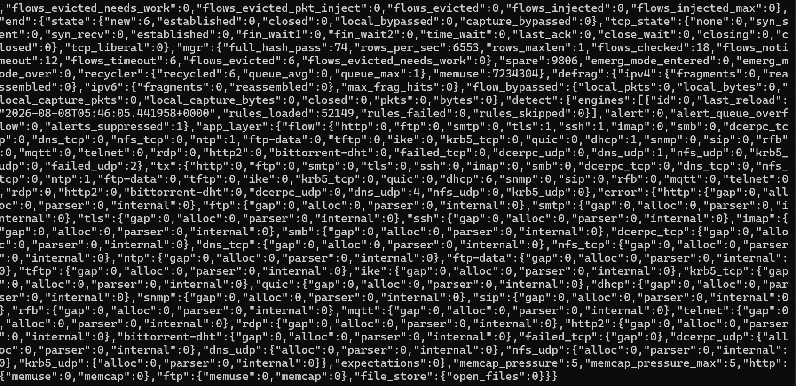

Step 6 – Create Custom Nmap Detection Rule
Created a local rule file:
sudo nano /etc/suricata/rules/local.rules
Added the following rule:
alert tcp any any -> $HOME_NET any \
(msg:"LOCAL NMAP SYN SCAN"; \
flags:S; \
threshold:type both, track by_src, count 20, seconds 10; \
classtype:attempted-recon; \
sid:1000001; rev:1;)
Rule Explanation:
Parameter | Purpose
flags | Detect SYN packets
count 20 | Trigger after 20 packets
seconds 10 | Within 10 seconds
classtype | Reconnaissance activity
sid | Unique rule identifier
Validated rule syntax:
Then
Copy the suricata.rules file form /var/lib/suricata/ to /etc/suricata/rules
And
naon /etc/suricata/suricta.yml
Drag down for and long time and find
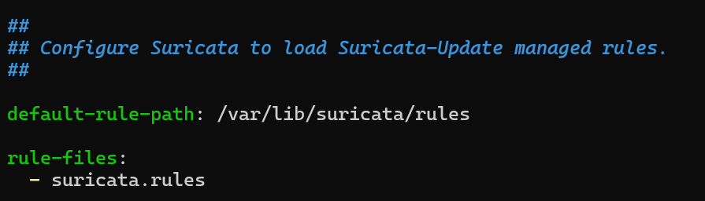 Change it to :
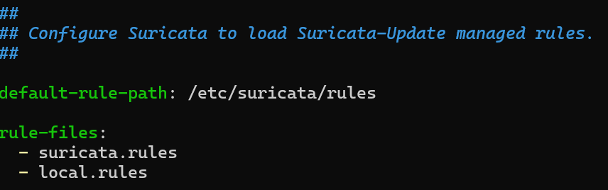
Then
sudo suricata -T -c /etc/suricata/suricata.yaml
Restarted Suricata:
sudo systemctl restart suricata

Screenshot Placeholder
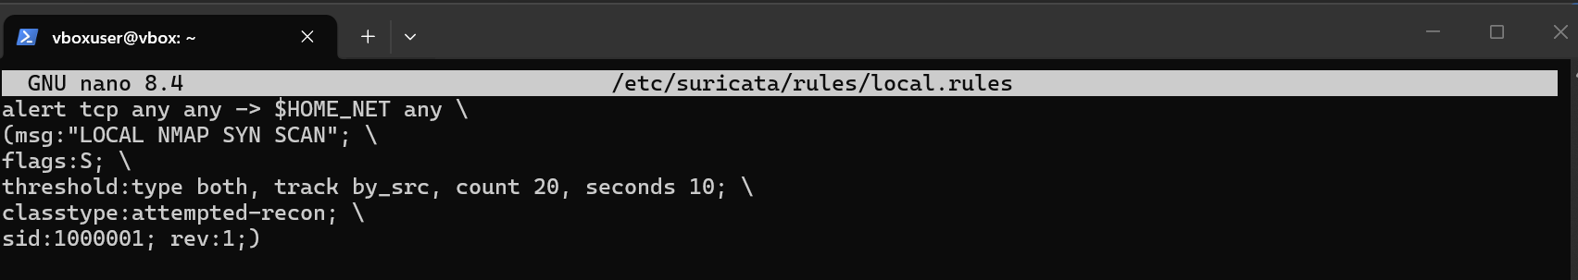

Step 7 – Configure Wazuh Agent
Edited Wazuh configuration:
sudo nano /var/ossec/etc/ossec.conf
Added:
<localfile>
<log_format>json</log_format>
<location>/var/log/suricata/eve.json</location>
</localfile>
Restarted agent:
sudo systemctl restart wazuh-agent
Purpose:
- Monitor Suricata JSON logs
- Forward alerts to Wazuh Manager

Screenshot Placeholder
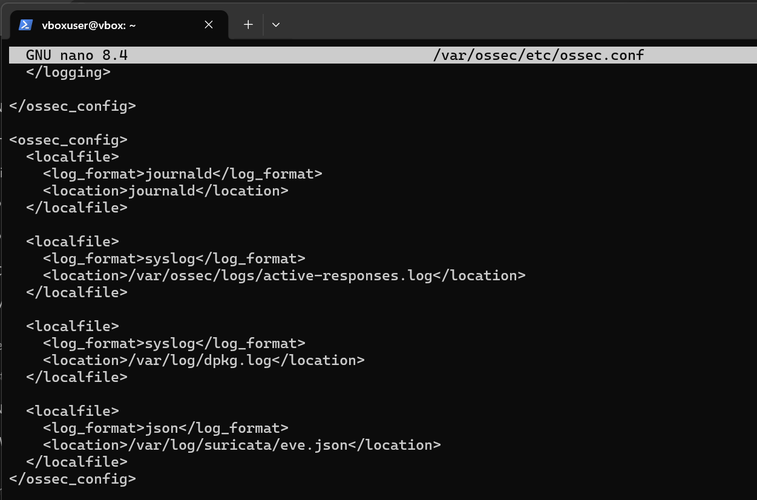

Step 8 – Create Wazuh Detection Rule
On the Wazuh Manager:
sudo -i
sudo nano /var/ossec/etc/rules/local_rules.xml
Added:
<group name="suricata,nmap,">
<rule id="100500" level="12">
<field name="alert.signature">LOCAL NMAP SYN SCAN</field>
<description>Nmap SYN Scan Detected</description>
<mitre>
<id>T1595</id>
</mitre>
</rule>
</group>
Restarted manager:
sudo systemctl restart wazuh-manager
Purpose:
- Generate high-priority alerts
- Map activity to MITRE ATT&CK T1595 (Active Scanning)

Screenshot Placeholder
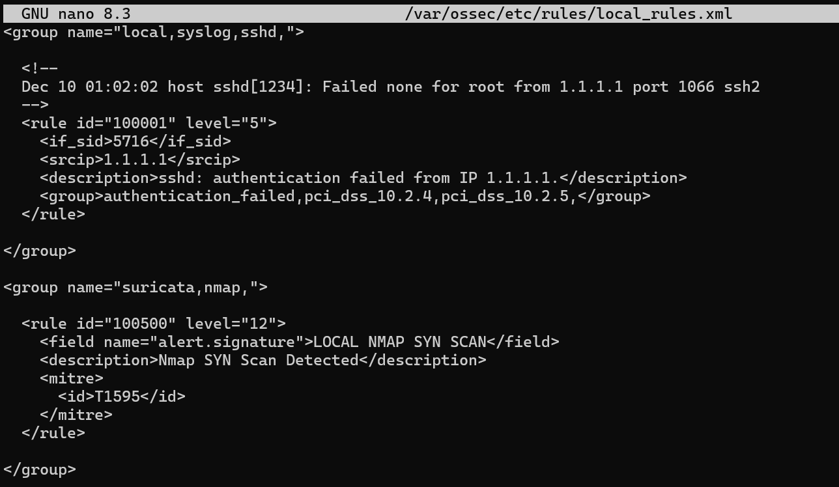

Step 9 – Generate Nmap Scan
From the attacker system:
nmap -sS 192.168.56.102
This generated SYN packets against the target system.

Screenshot Placeholder
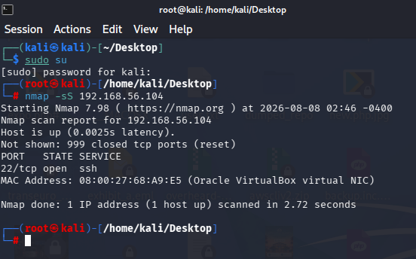

Step 10 – Verify Suricata Detection
Search alerts:
grep -a "LOCAL NMAP SYN SCAN" /var/log/suricata/eve.json
Observed alert:
{
"event_type":"alert",
"alert":{
"signature":"LOCAL NMAP SYN SCAN"
}
}

Screenshot Placeholder
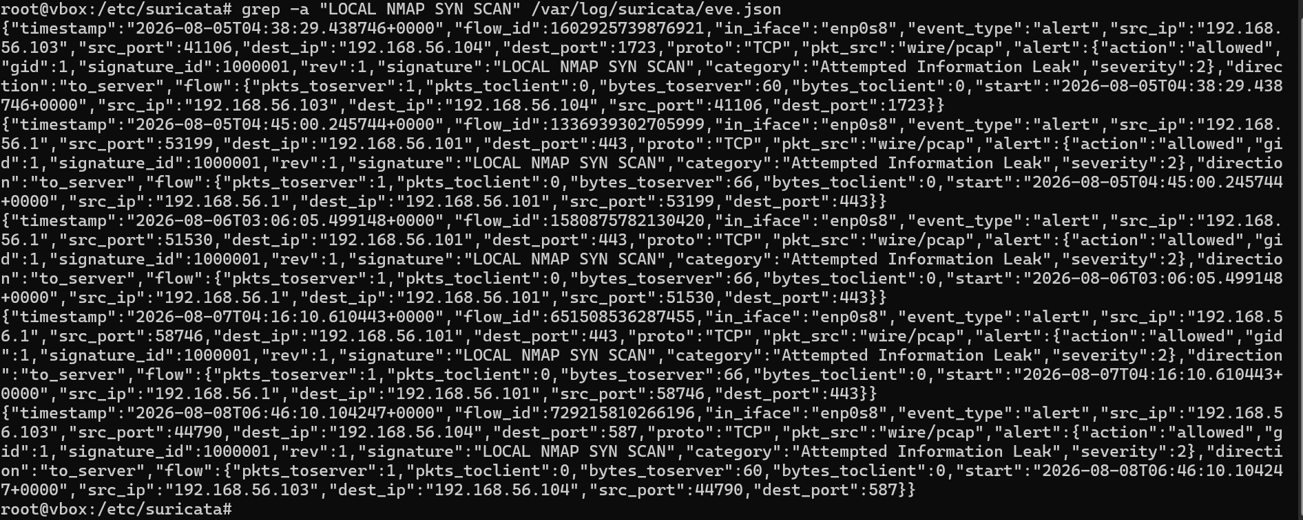

Step 11 – Verify Wazuh Alert
Check alerts:
tail -f /var/ossec/logs/alerts/alerts.json
Observed:
Rule ID: 100500
Level: 12
Description: Nmap SYN Scan Detected
Source IP: <Attacker IP>
Dashboard verification confirmed that the alert was received and processed successfully.

Screenshot Placeholder
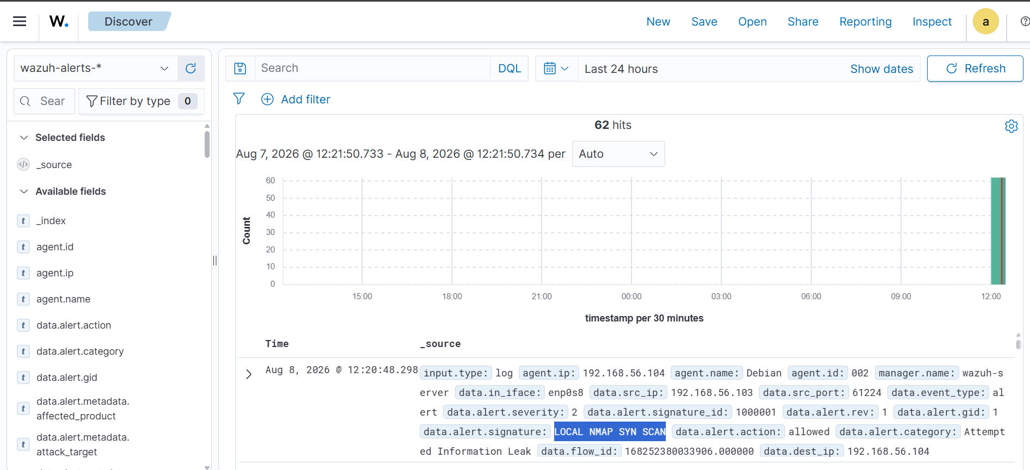

Troubleshooting Performed

UFW Logging Attempt
Initially, UFW logging was evaluated for Nmap detection.
Issue encountered:
ERROR: problem running sysctl
Investigation showed:
sudo sysctl --system
My Debian system didn’t have sysctl file.
Decision:
- UFW logging was not used.
- Suricata was selected because it provides protocol-aware detection and structured JSON output suitable for Wazuh integration.
- I also performed File integrity monitoring on /var/ssh/sshd_conf to perform it I would recommend you to read
- https://documentation.wazuh.com/current/user-manual/capabilities/file-integrity/advanced-settings.html#who-data-monitoring

Screenshot Placeholder
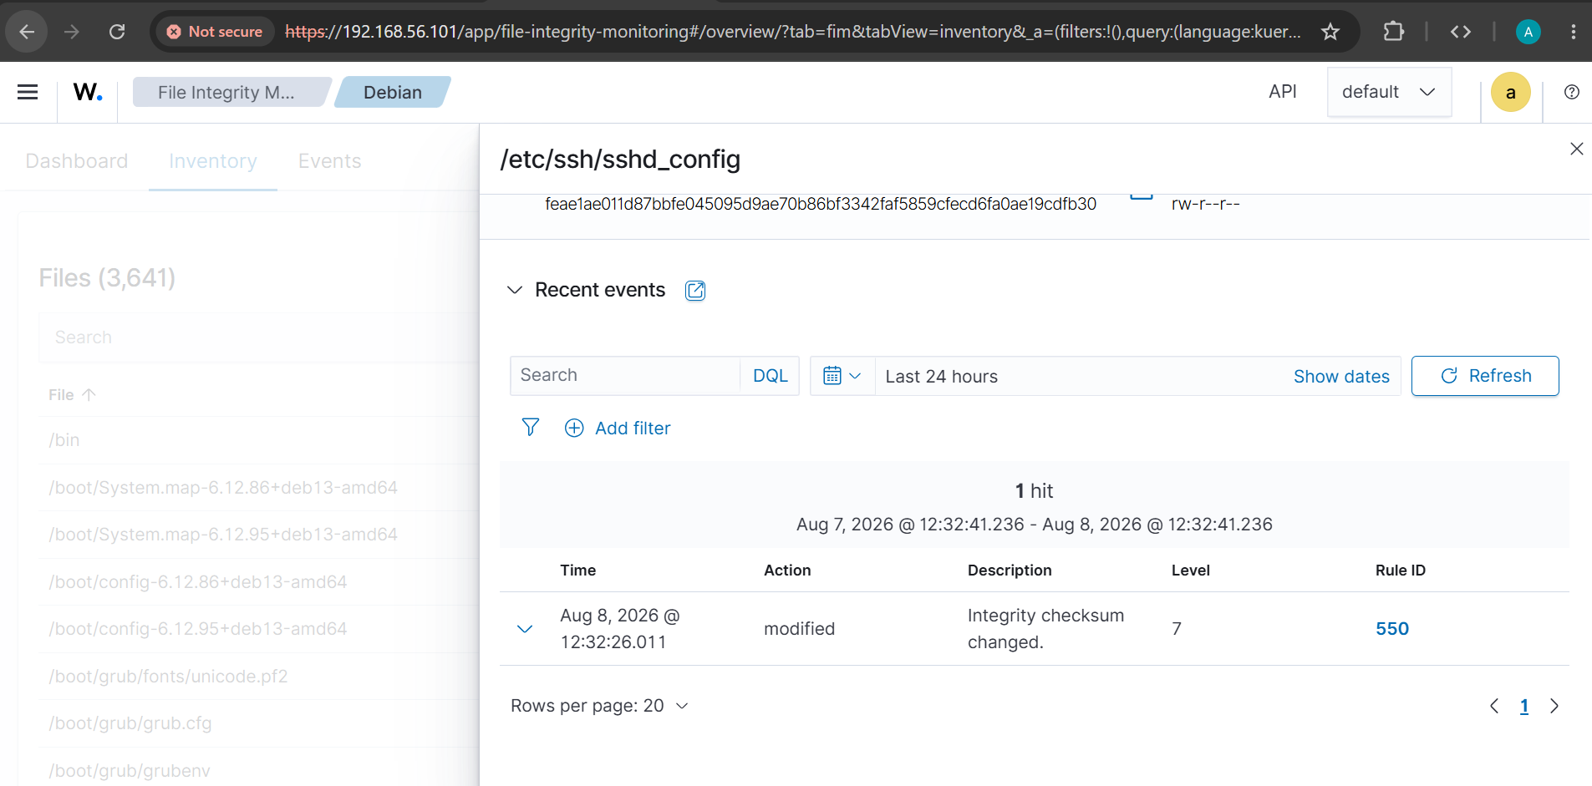

Results
The implementation successfully achieved the objective.

Successful Outcomes
- Suricata installed and operational.
- Emerging Threats rules loaded.
- Custom Nmap SYN detection rule created.
- Suricata generated alerts upon Nmap scanning.
- Wazuh agent collected Suricata events.
- Wazuh manager generated alerts.
- Detection mapped to MITRE ATT&CK framework.
- Alerts visible in the Wazuh Dashboard.

Screenshot Placeholder
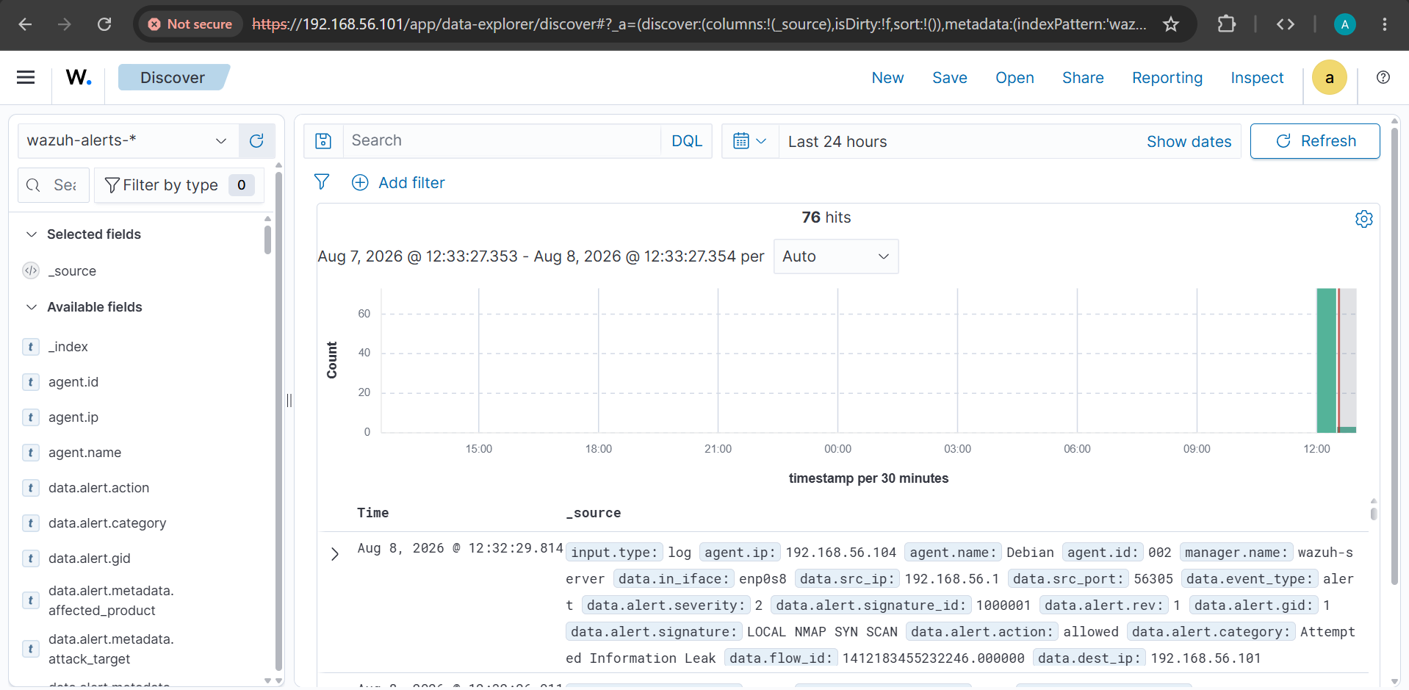

Conclusion
A complete Suricata-to-Wazuh integration was successfully implemented on Debian 13. The environment detected Nmap SYN scans in real time and generated corresponding alerts within Wazuh. This approach provides significantly better visibility and detection capabilities than relying solely on firewall logs and forms a strong foundation for network intrusion detection and security monitoring.

